**Tugas 1**

Nama : Anang Febryan

Kampus : STT Terpadu Nurul Fikri

**Output**

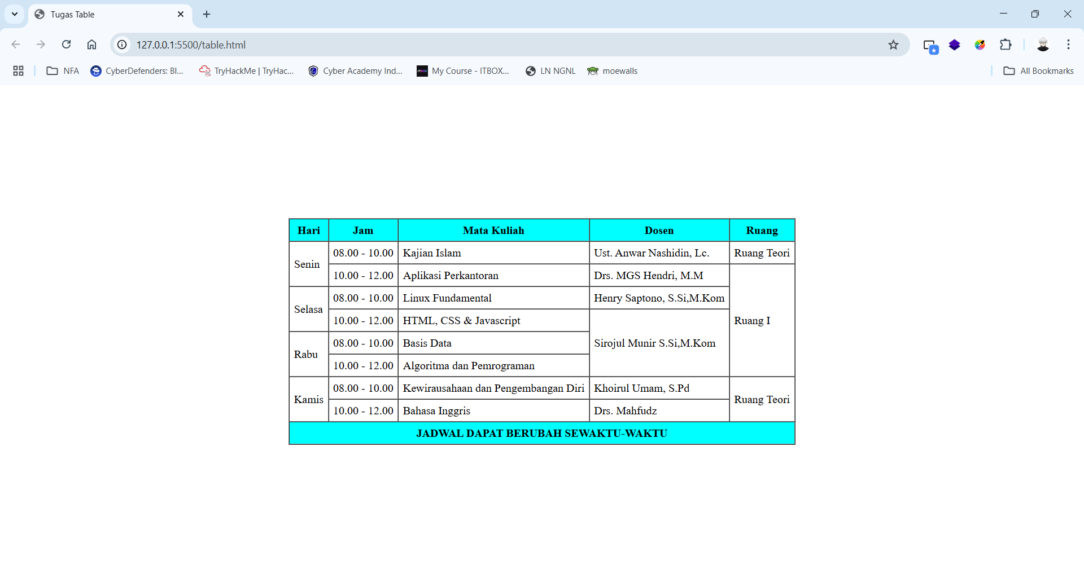

**Link Drive** <https://drive.google.com/drive/folders/128SF1fQ-EmfODxxSowjD_AGsIZ05oxoc?usp=drive_link>